Assessment Schedule – 2016

Physics: Demonstrate understanding of mechanical systems (91524)

Evidence Statement
NØ | N1 | N2 | A3 | A4 | M5 | M6 | E7 | E8
No response; no relevant evidence. | 1A | 2A or 1M | 3A or 1A + 1M or 1E | 4A or 2A + 1M  or 2M or 1A + 1E | 1A + 2M or 1M+1E  or 3A + 1M  or 2A + 1E | 2A + 2M or 3M  or 3A + 1E  or A+ M + 1E | 2M + 1E-  or 2A+ M + 1E–  or 1A + 2M + 1E– | 1A + 2M + 1E
Other combinations are also possible using a = 1, m = 2 and e = 3. However, for M5 or M6 at least one Merit question needs to be correct (maximum 6). For E7 or E8 at least one Excellence needs to be correct (maximum 8). Note: E- and E only applies to the E7 and E8 decision
Q | Evidence |  | Achievement | Merit | Excellence
ONE  (a) | 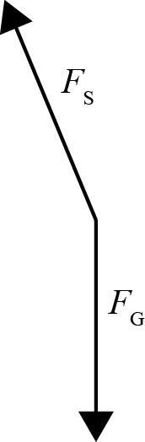 | OR  - support force  - reaction force  - normal force  - normal reaction force  (Do not accept lift or tension force)  OR  - gravity force  - weight force | Correct answer.
(b) | 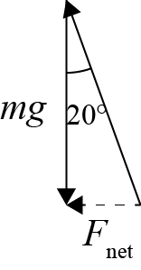  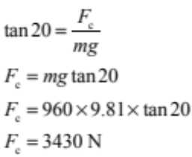 |  | Correct diagram.  OR  Correct calculation and answer.  OR  Calculates F_{c} correctly but using g = 9.8 m s^{–2}  not 9.81 m s^{–2}.  (F_{c} = 3420 N) | Correct diagram  AND  Correct calculation and answer.

(c) | At Position A there is no acceleration so the force from the track equals the gravity force.  At Position B, the car is moving in a vertical circle.  So the car is accelerating upwards, so the force from the track is greater than the gravity force.  OR  At B the car is moving in a vertical circle, so it is accelerating up, so the force the track exerts at B is bigger than that at A. | Complete answer for Position A (Accept the force from the track equals the gravity force)  OR  Complete answer for Position B (Accept the force from the track is greater than the gravity force)  OR  Partial explanation for both positions. | Complete answer with links between concepts.
(d) | 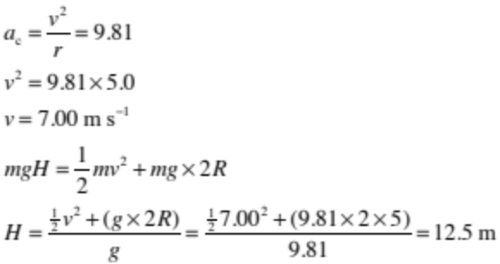 | Recognises that gravitational potential energy (GPE) at the top is equal to GPE + E_{k} at the top of the loop.  OR  Recognises that a_{c} = 9.81. | Calculates speed  OR  Calculates H correctly but with incorrect speed. | Correct calculation and correct answer. (E)  Note:  Accept 7.5 m for correct working if mgR is used instead of mg2R for (E–).

Q | Evidence | Achievement | Merit | Excellence
TWO  (a) | Gravitational potential energy to both linear and rotational kinetic energy. | Correct answer.
(b) | 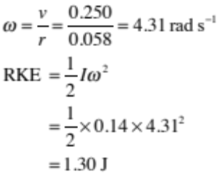 | Correct angular speed  OR  correct energy equation using incorrect angular speed. | Correct calculation and answer.
(c) | 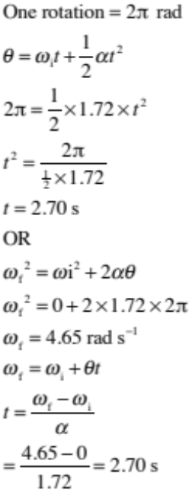 | Correctly converts rotation to radians.  OR  Correct calculation as evidenced by having SHOWN WORKING.  OR  Correct final angular velocity  (ω_{f} = 4.65 rad s^{–1}).  OR  Allow A for follow on error for ω_{f} often giving t = 2.50 s. | Correct calculation and answer.

(d) | The solid cylinder has a smaller rotational inertia since its mass is closer to centre compared to the hollow cylinder.  Hence it will have a smaller proportion of rotational kinetic energy and a larger proportion of linear kinetic energy.  (Since they both have the same amount of gravitational potential energy), the one with the greater proportion of linear kinetic energy will reach the bottom first.  OR (Both cylinders will also have the same torque since they both have the same shape and mass.) The solid cylinder has its mass closer to the centre. So it has less rotational inertia so will have greater angular acceleration (since τ = Iα).  So will take less time to reach bottom. | One correct idea, e.g.:  - Solid cylinder has less rotational inertia.  - Or both have same torque.  - Or solid cylinder has smaller “effective radius”.  - Or solid cylinder has mass closer to centre.  (Accept converse arguments based on hollow cylinder also.)  Accept inertia in place of rotational inertia. | Two key ideas linked, e.g.:  Solid cylinder has less rotational inertia because mass is closer to centre.  OR  Solid cylinder has less rotational Inertia so will have less Rotational Kinetic energy (since E_{KR}=1 / 2 Iω²)  OR  Solid cylinder has less rotational inertia so will have more linear kinetic energy.  (Accept converse arguments based on hollow cylinder also.)  Accept inertia in place of rotational inertia. | Complete correct succinct explanation. (E)  Complete explanation with minor errors. (E–)  Accept inertia in place of rotational inertia.

Q | Evidence | Achievement | Merit | Excellence
THREE  (a) | The acceleration (or restoring force) is proportional to displacement and is (acts) in the opposite direction to displacement.  Accept equations in the explanation e.g. (a = -ω²y), (a α –y), (F = -ky) or  (F α –y) | Both points stated.
(b) | 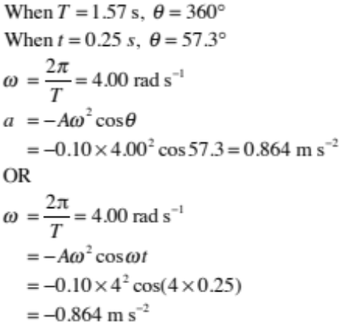 | Correct angle for t = 0.25 s.  OR  Correct value for angular frequency.  OR  Use of suitable equation 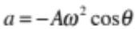 | One error in calculation.  e.g.:  Forgot to square ω.  OR  Used 10.0cm instead of 0.10m. | Correct calculation and correct answer for acceleration with unit. (E)  Correct calculation and answer for acceleration without unit. (E-)
(c) | This is an example of resonance. Tom must put energy into the system (the driving frequency) at the natural frequency. The natural frequency is the frequency at which the bumble bee will normally oscillate. (Amplitude increases until energy input equals kinetic energy lost as heat.) | Idea of resonance or that the frequency of the driver matches the natural frequency of the spring.  OR  “Resonance” stated but not explained. | Idea of resonance including the word “Resonance”.  AND  Links matching driving frequency to natural frequency.  OR  Explains maximum amplitude.
(d) | 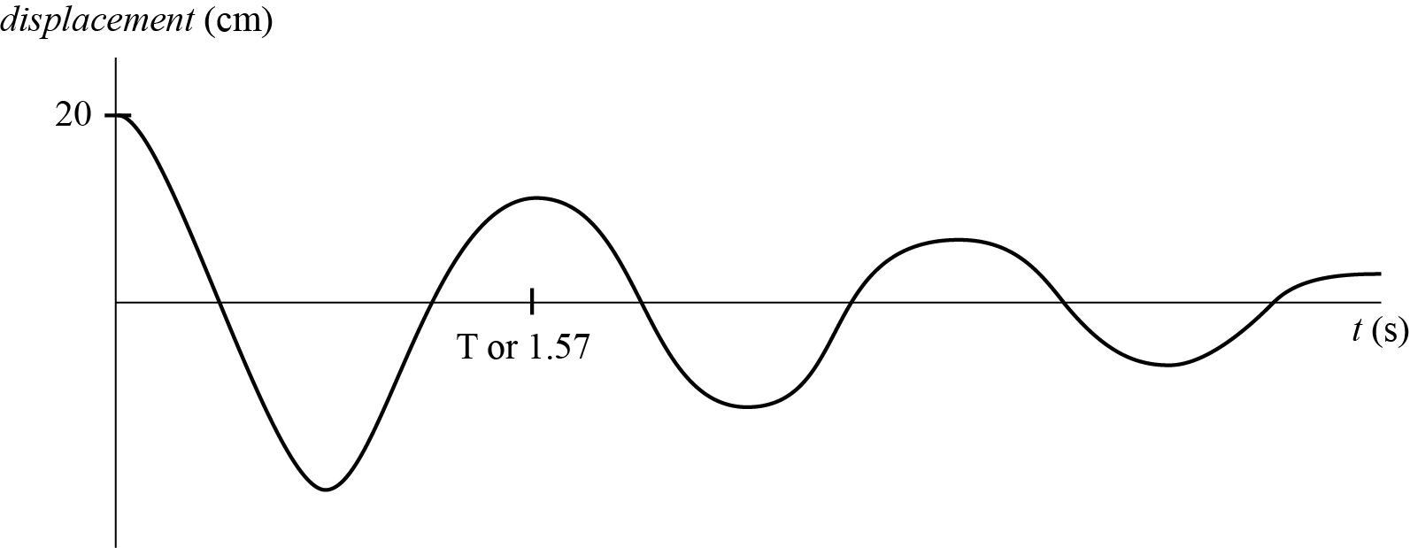 | Correct damped shape starting from +y for 3 complete cycles.  OR  Constant amplitude if no damping statement given for 3 complete cycles. | Correct damped shape for 3 complete cycles and constant period and at least one value on axes (A₀ = 20 cm, and T = 1.57 s).  OR  States assumptions of zero damping and the graph shows this 3 complete cycles. Constant period and at least one value on axes (A₀ = 20 cm, and T = 1.57 s).

Cut Scores
Not Achieved | Achievement | Achievement with Merit | Achievement with Excellence
0 – 6 | 7 – 13 | 14 – 18 | 19 – 24

